Spheroid
# Source: AI Source: Provided by: [Data Path: Persons Table -> ID Column: 1, Name_En Column: Motasem Essam] -> From: [ChatGPT] on [7/25/2026]
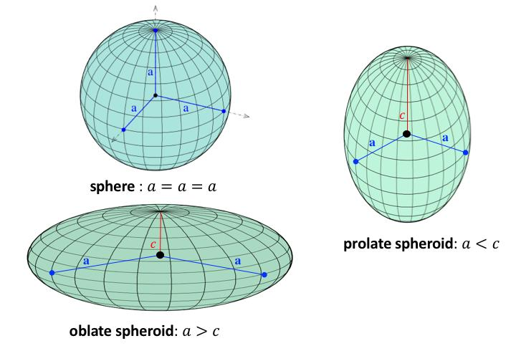
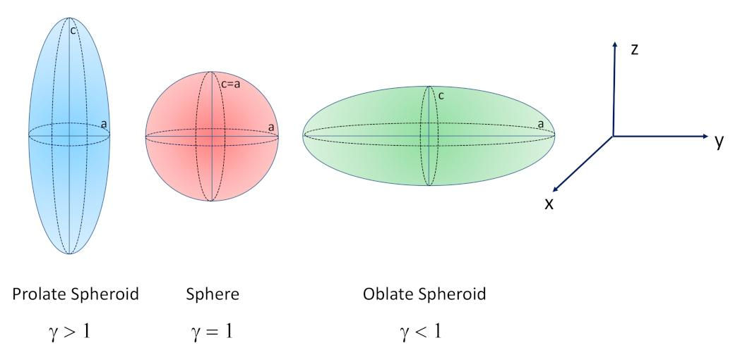
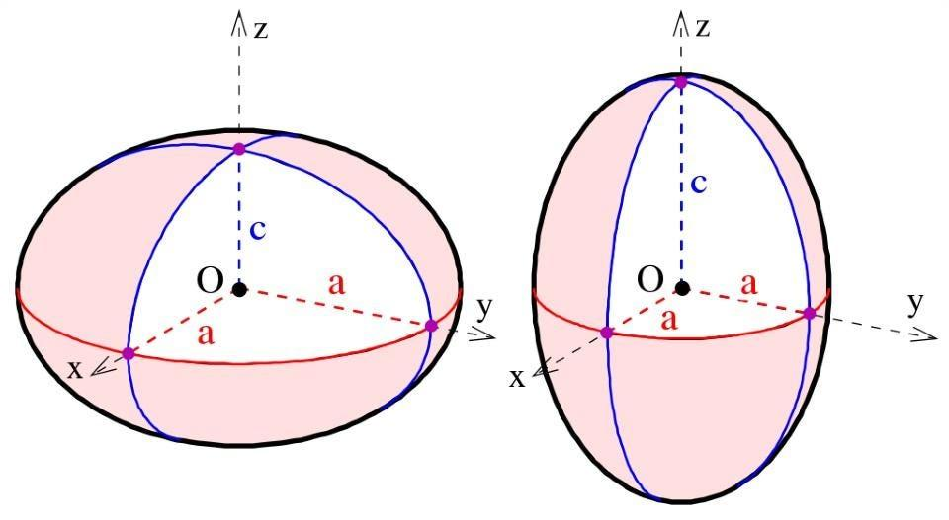

Definition
# Source: AI Source: Provided by: [Data Path: Persons Table -> ID Column: 1, Name_En Column: Motasem Essam] -> From: [ChatGPT] on [7/25/2026]
A spheroid is a three-dimensional geometric solid formed by rotating an ellipse about one of its principal axes. It is a special type of ellipsoid in which two of the three principal semiaxes are equal.
A spheroid has two characteristic radii:
- Equatorial radius ($a$): the radius perpendicular to the axis of rotation.
- Polar radius ($c$): the radius along the axis of rotation.
Depending on the relationship between these radii, a spheroid can be flattened, elongated, or spherical.

Simple Definition
# Source: AI Source: Provided by: [Data Path: Persons Table -> ID Column: 1, Name_En Column: Motasem Essam] -> From: [ChatGPT] on [7/25/2026]
A spheroid is a sphere-like three-dimensional shape that may be flattened at the poles, stretched along the poles, or perfectly round.

Types of Spheroids
# Source: AI Source: Provided by: [Data Path: Persons Table -> ID Column: 1, Name_En Column: Motasem Essam] -> From: [ChatGPT] on [7/25/2026]
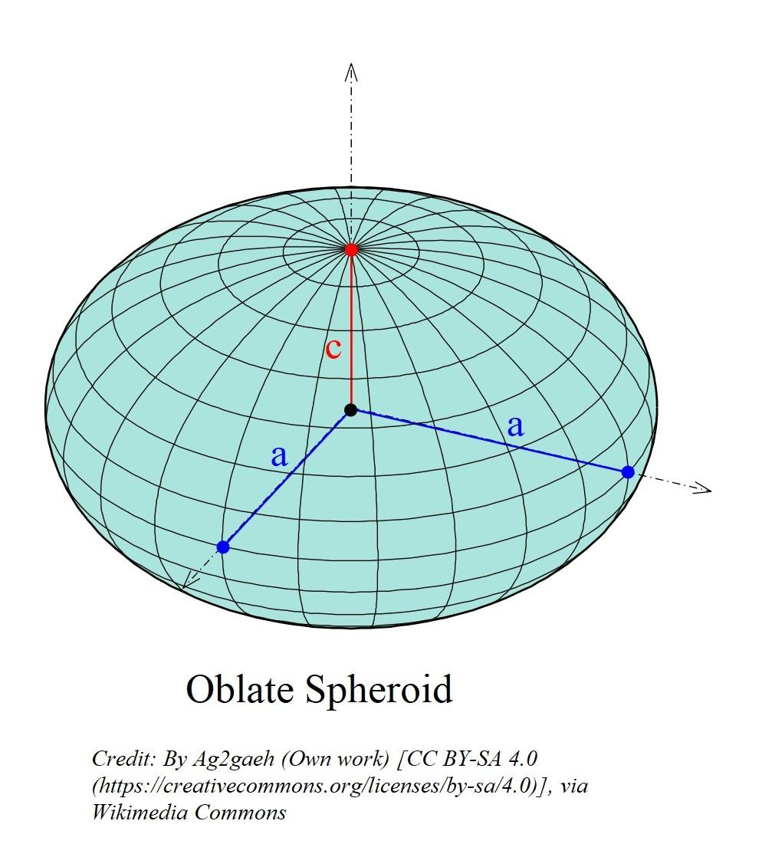

Oblate Spheroid
# Source: AI Source: Provided by: [Data Path: Persons Table -> ID Column: 1, Name_En Column: Motasem Essam] -> From: [ChatGPT] on [7/25/2026]
An oblate spheroid is flattened along its polar axis and wider around its equator.
$$a>c$$
Example: Earth is approximately an oblate spheroid.

Prolate Spheroid
# Source: AI Source: Provided by: [Data Path: Persons Table -> ID Column: 1, Name_En Column: Motasem Essam] -> From: [ChatGPT] on [7/25/2026]
A prolate spheroid is elongated along its polar axis and narrower around its equator.
$$c>a$$
Example: An elongated ellipsoidal model used in mathematical and physical calculations.
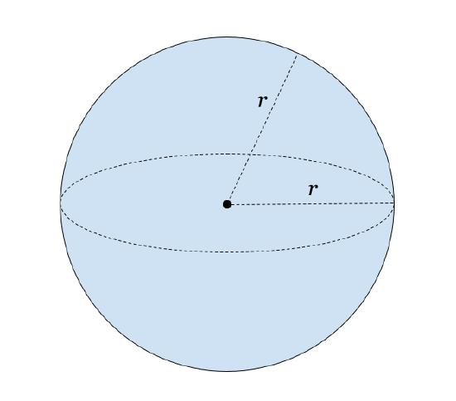

Spherical Case
# Source: AI Source: Provided by: [Data Path: Persons Table -> ID Column: 1, Name_En Column: Motasem Essam] -> From: [ChatGPT] on [7/25/2026]
When the equatorial and polar radii are equal, the spheroid becomes a perfect sphere.
$$a=c=R$$
All directions through the center have the same radius.

Geometric Components
# Source: AI Source: Provided by: [Data Path: Persons Table -> ID Column: 1, Name_En Column: Motasem Essam] -> From: [ChatGPT] on [7/25/2026]
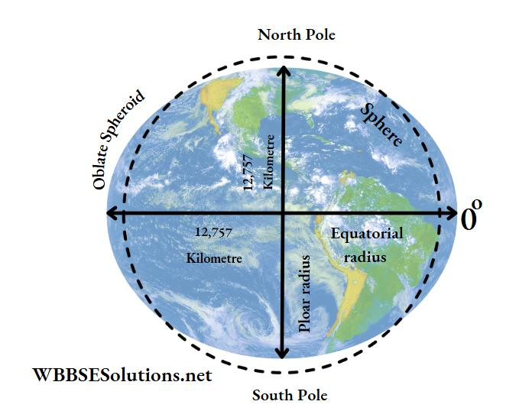
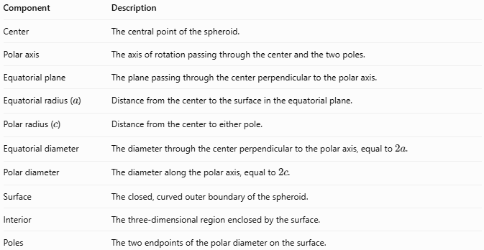
Component | Description
Center | The central point of the spheroid.
Polar axis | The axis of rotation passing through the center and the two poles.
Equatorial plane | The plane passing through the center perpendicular to the polar axis.
Equatorial radius ($a$) | Distance from the center to the surface in the equatorial plane.
Polar radius ($c$) | Distance from the center to either pole.
Equatorial diameter | The diameter through the center perpendicular to the polar axis, equal to $2a$.
Polar diameter | The diameter along the polar axis, equal to $2c$.
Surface | The closed, curved outer boundary of the spheroid.
Interior | The three-dimensional region enclosed by the surface.
Poles | The two endpoints of the polar diameter on the surface.

Key Characteristics
# Source: AI Source: Provided by: [Data Path: Persons Table -> ID Column: 1, Name_En Column: Motasem Essam] -> From: [ChatGPT] on [7/25/2026]
- A spheroid is a three-dimensional solid.
- It is rotationally symmetric about its polar axis.
- Every cross-section perpendicular to the polar axis is a circle, except for a degenerate cross-section at a pole.
- A cross-section through the polar axis is an ellipse.
- Two principal semiaxes are equal, while the third may differ.
- The spheroid has a single geometric center.
- A sphere is the special case in which all three principal semiaxes are equal.

Mathematical Formulas

General Equation
# Source: AI Source: Provided by: [Data Path: Persons Table -> ID Column: 1, Name_En Column: Motasem Essam] -> From: [ChatGPT] on [7/25/2026]
For a spheroid centered at the origin, with the polar axis along the $z$-axis:
$$\boxed{\frac{x^{2}}{a^{2}}+\frac{y^{2}}{a^{2}}+\frac{z^{2}}{c^{2}}=1}$$
Where $a$ is the equatorial radius and $c$ is the polar radius.

Diameters
# Source: AI Source: Provided by: [Data Path: Persons Table -> ID Column: 1, Name_En Column: Motasem Essam] -> From: [ChatGPT] on [7/25/2026]
Equatorial diameter:
$$\boxed{D_{e}=2a}$$
Polar diameter:
$$\boxed{D_{p}=2c}$$

Volume
# Source: AI Source: Provided by: [Data Path: Persons Table -> ID Column: 1, Name_En Column: Motasem Essam] -> From: [ChatGPT] on [7/25/2026]
The volume formula applies to all spheroids:
$$\boxed{V=\frac{4}{3}πa^{2}c}$$
For a sphere, $a=c=R$, so the formula reduces to:
$$V=\frac{4}{3}πR^{3}$$

Eccentricity
# Source: AI Source: Provided by: [Data Path: Persons Table -> ID Column: 1, Name_En Column: Motasem Essam] -> From: [ChatGPT] on [7/25/2026]
Eccentricity measures the difference between the equatorial and polar radii.
For an oblate spheroid, where $a>c$:
$$e=\sqrt{1-\frac{c^{2}}{a^{2}}}$$
For a prolate spheroid, where $c>a$:
$$e=\sqrt{1-\frac{a^{2}}{c^{2}}}$$
For a sphere:
$$e=0$$

Flattening
# Source: AI Source: Provided by: [Data Path: Persons Table -> ID Column: 1, Name_En Column: Motasem Essam] -> From: [ChatGPT] on [7/25/2026]
Flattening is commonly used for oblate spheroids:
$$\boxed{f=\frac{a-c}{a}}$$
For a prolate spheroid, an analogous signed quantity is negative. To describe elongation positively, use:
$$\boxed{f_{p}=\frac{c-a}{a}}$$

Worked Examples
# Source: AI Source: Provided by: [Data Path: Persons Table -> ID Column: 1, Name_En Column: Motasem Essam] -> From: [ChatGPT] on [7/25/2026]
Example 1 — Identify the Type
A spheroid has an equatorial radius of $8\text{ cm}$ and a polar radius of $5\text{ cm}$. Identify its type.
Since
$$a=8, c=5$$
and $a>c$, it is an oblate spheroid.
Example 2 — Calculate the Volume
A spheroid has $a=4\text{ cm}$ and $c=7\text{ cm}$.
$$V=\frac{4}{3}πa^{2}c$$
$$V=\frac{4}{3}π\left(4^{2}\right)\left(7\right)$$
$$\boxed{V=\frac{448}{3}π{\text{ cm}}^{3}}$$
Approximately:
$$V≈469.14{\text{ cm}}^{3}$$
Since $c>a$, this spheroid is prolate.
Example 3 — Calculate the Diameters
Given $a=6\text{ cm}$ and $c=9\text{ cm}$:
$$D_{e}=2\left(6\right)=12\text{ cm}$$
$$D_{p}=2\left(9\right)=18\text{ cm}$$
The polar diameter is $6\text{ cm}$ greater than the equatorial diameter, so the spheroid is prolate.

Constructing a Spheroid

Geometric Instruments
# Source: AI Source: Provided by: [Data Path: Persons Table -> ID Column: 1, Name_En Column: Motasem Essam] -> From: [ChatGPT] on [7/25/2026]
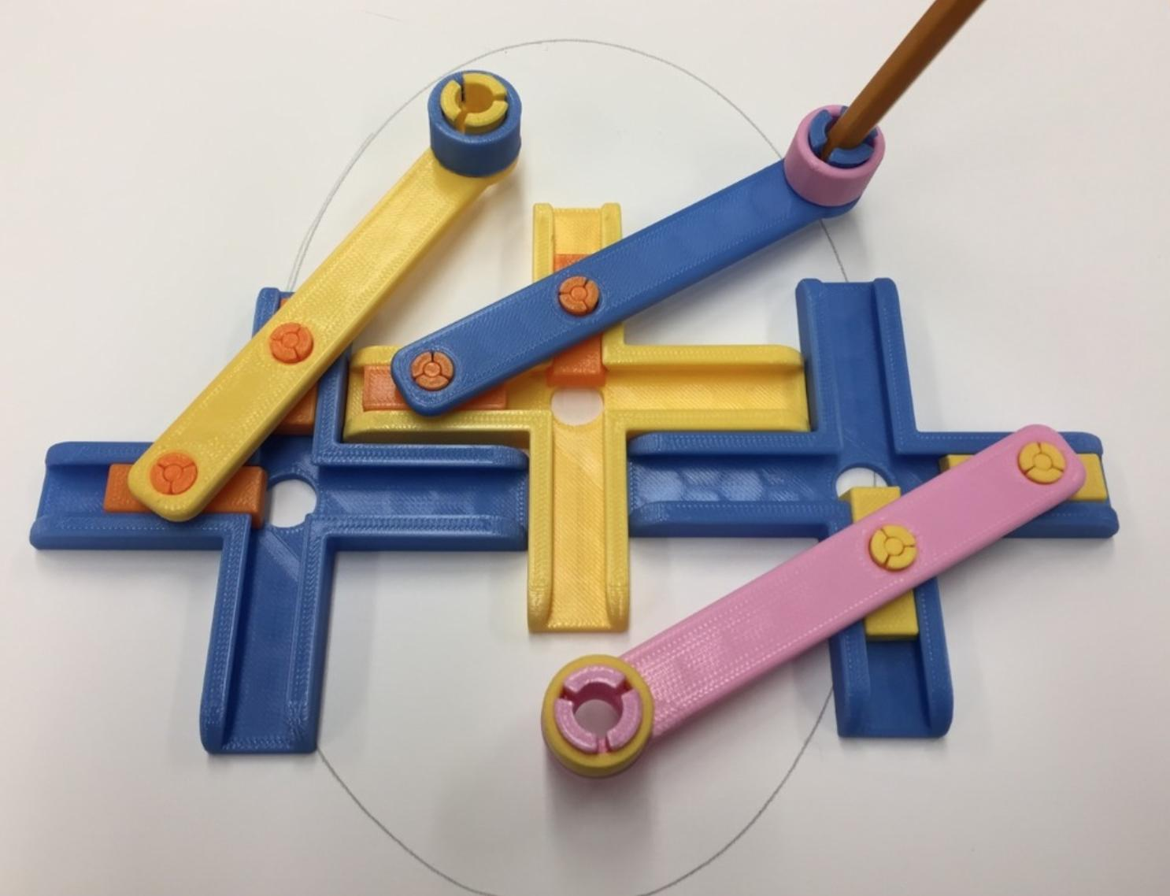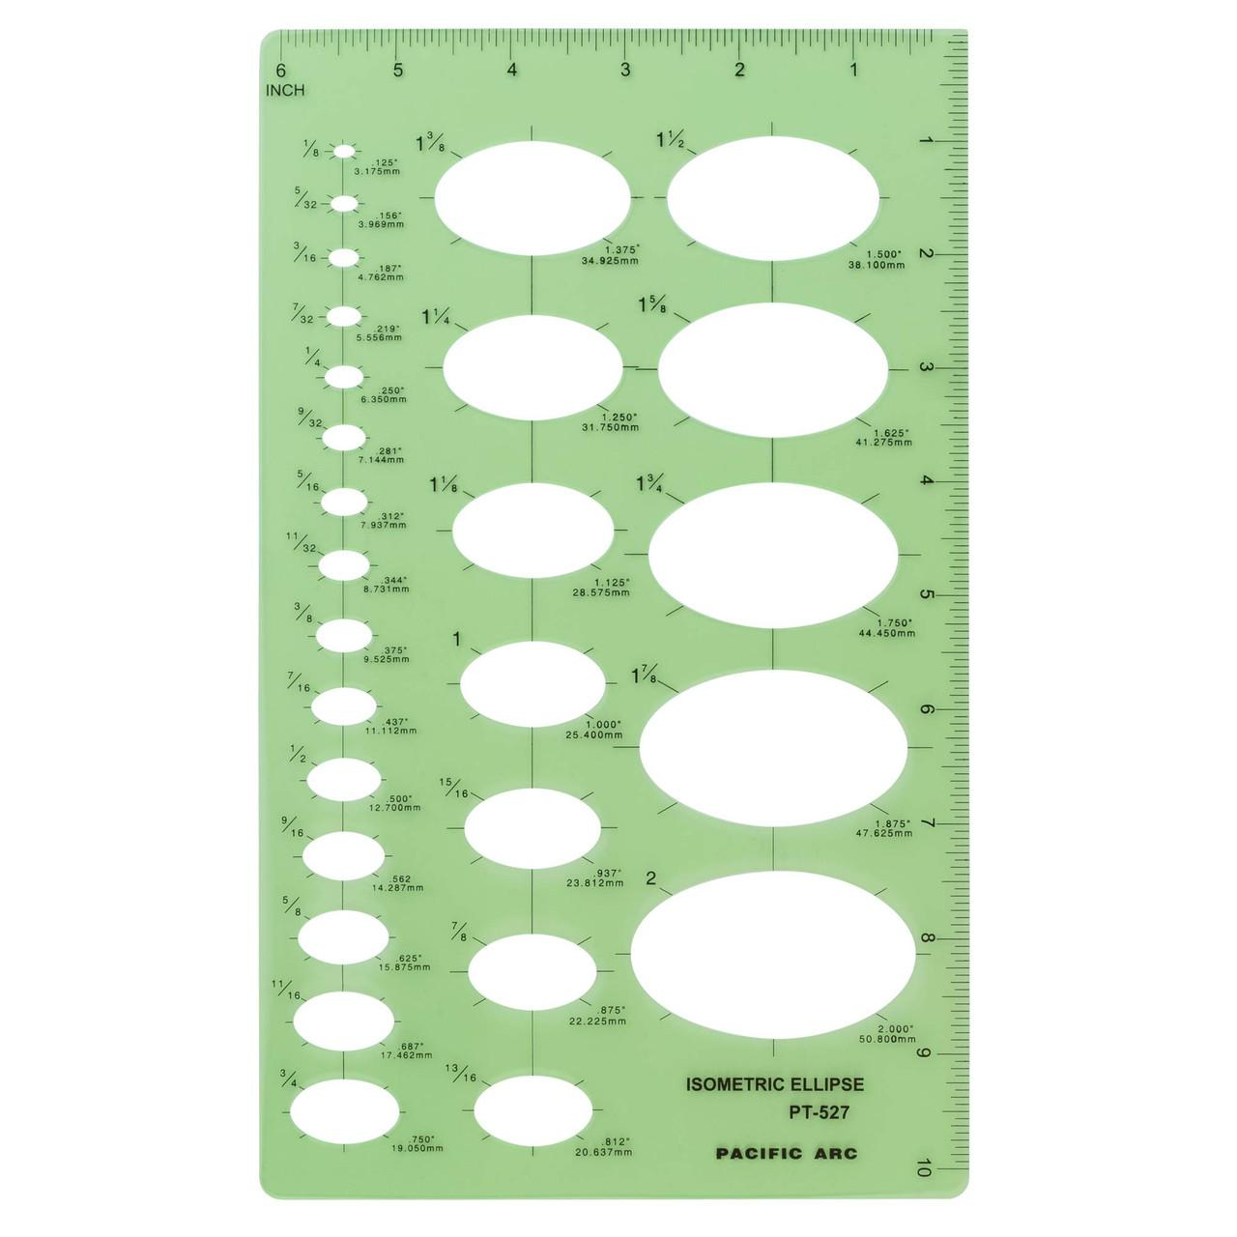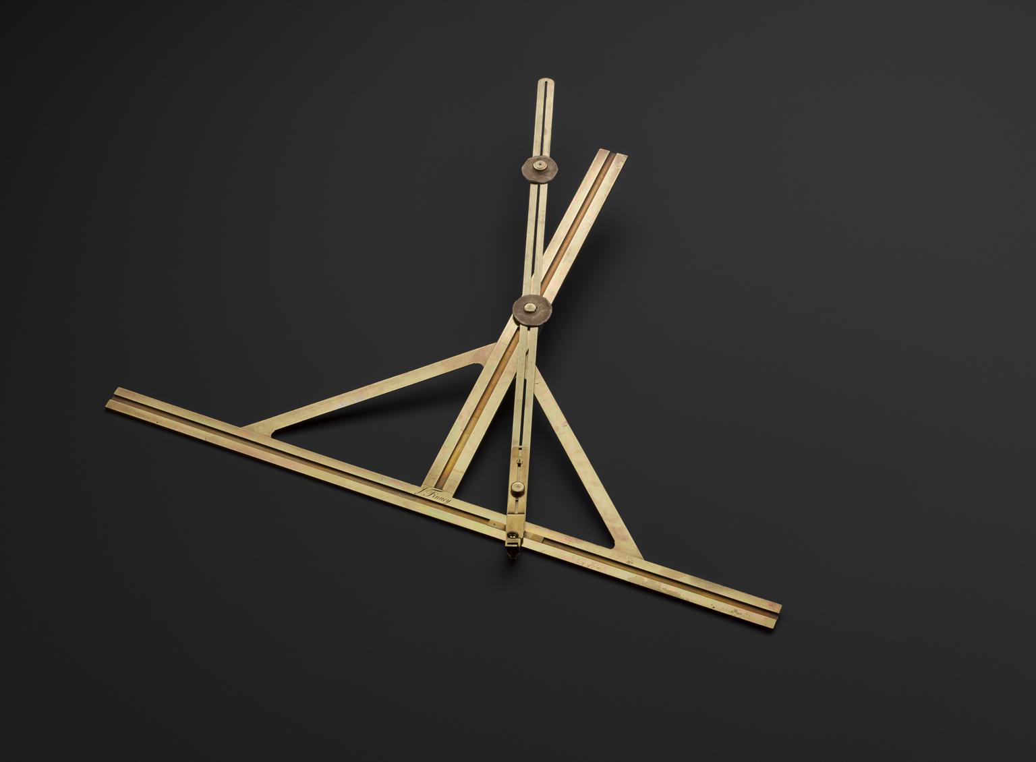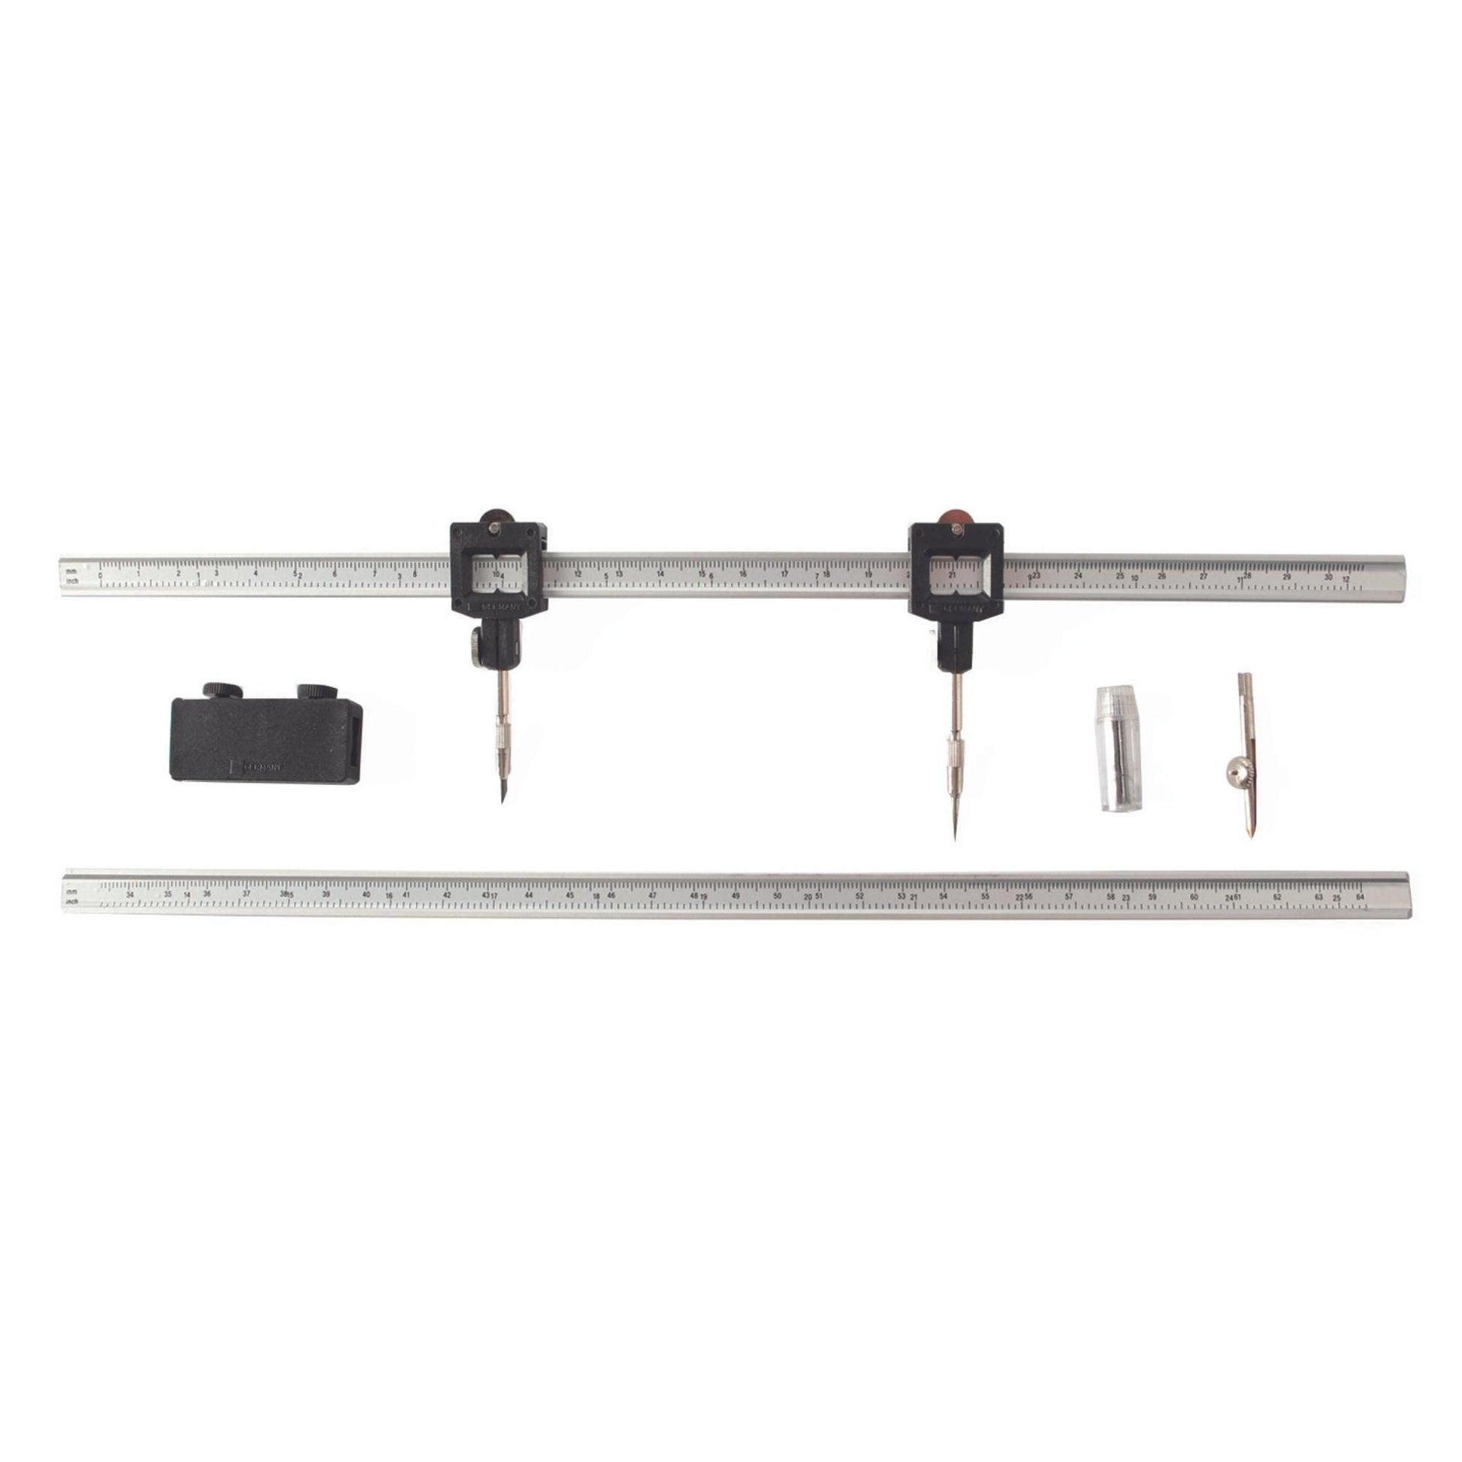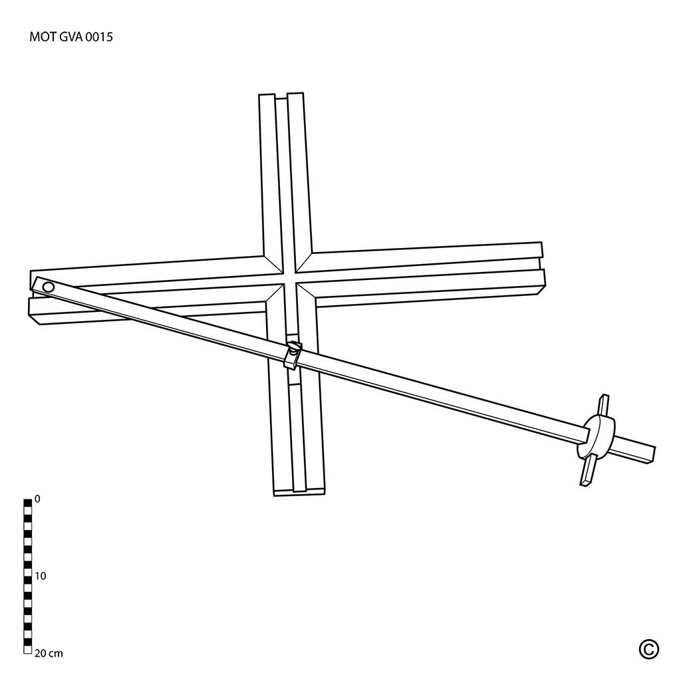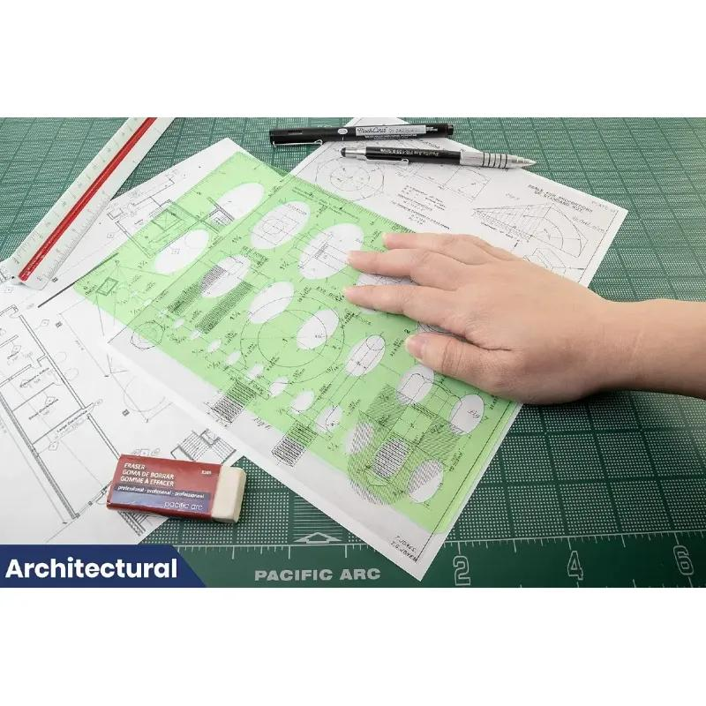
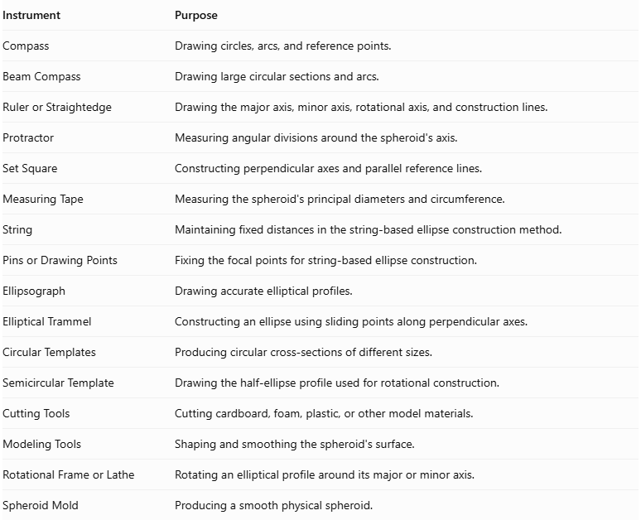
Instrument | Purpose
Compass | Drawing circles, arcs, and reference points.
Beam Compass | Drawing large circular sections and arcs.
Ruler or Straightedge | Drawing the major axis, minor axis, rotational axis, and construction lines.
Protractor | Measuring angular divisions around the spheroid's axis.
Set Square | Constructing perpendicular axes and parallel reference lines.
Measuring Tape | Measuring the spheroid's principal diameters and circumference.
String | Maintaining fixed distances in the string-based ellipse construction method.
Pins or Drawing Points | Fixing the focal points for string-based ellipse construction.
Ellipsograph | Drawing accurate elliptical profiles.
Elliptical Trammel | Constructing an ellipse using sliding points along perpendicular axes.
Circular Templates | Producing circular cross-sections of different sizes.
Semicircular Template | Drawing the half-ellipse profile used for rotational construction.
Cutting Tools | Cutting cardboard, foam, plastic, or other model materials.
Modeling Tools | Shaping and smoothing the spheroid's surface.
Rotational Frame or Lathe | Rotating an elliptical profile around its major or minor axis.
Spheroid Mold | Producing a smooth physical spheroid.

Instrument-Based Construction Procedures

Method 1: Constructing a Spheroid Using an Elliptical Profile and Rotational Symmetry
# Source: AI Source: Provided by: [Data Path: Persons Table -> ID Column: 1, Name_En Column: Motasem Essam] -> From: [ChatGPT] on [7/25/2026]
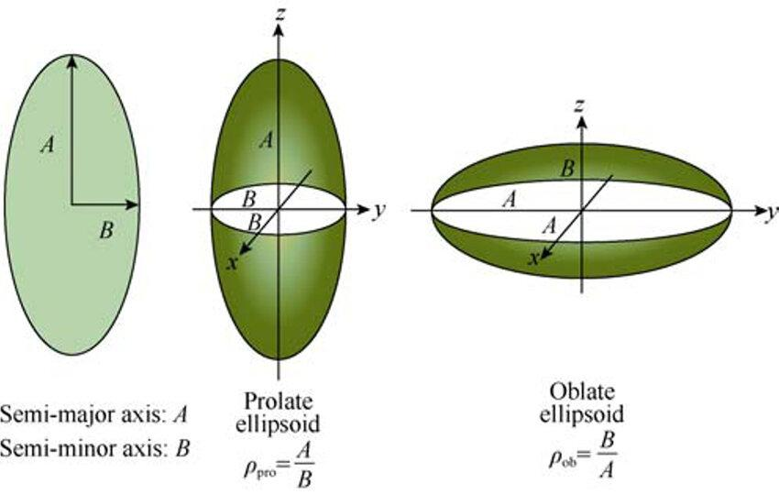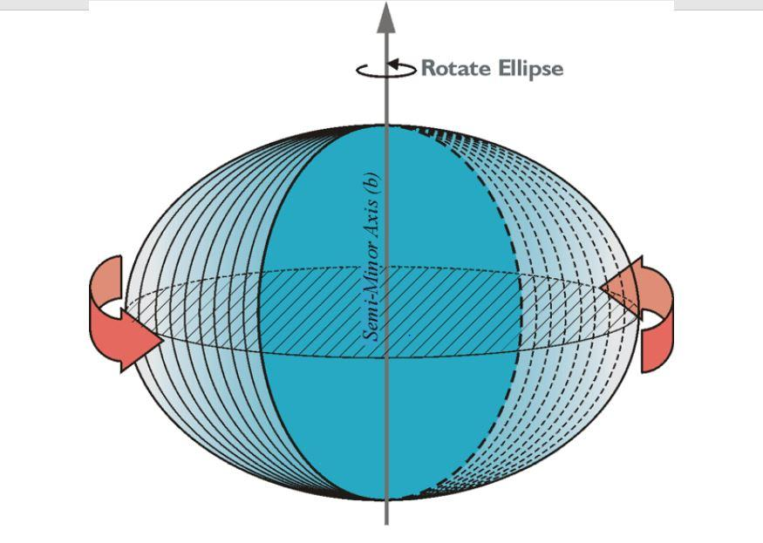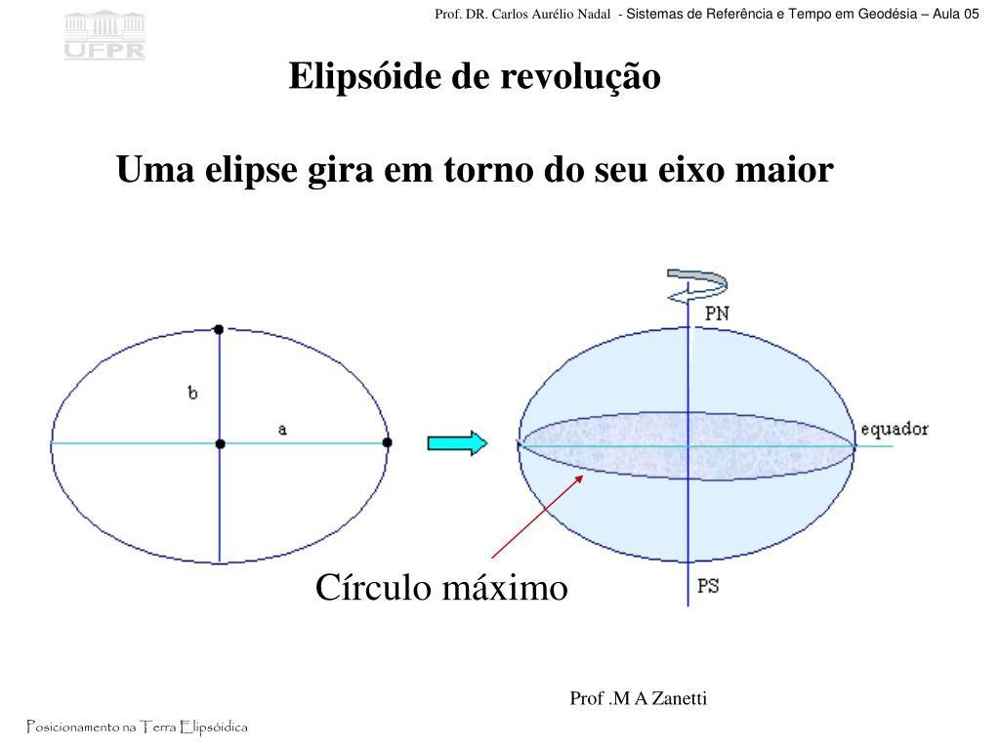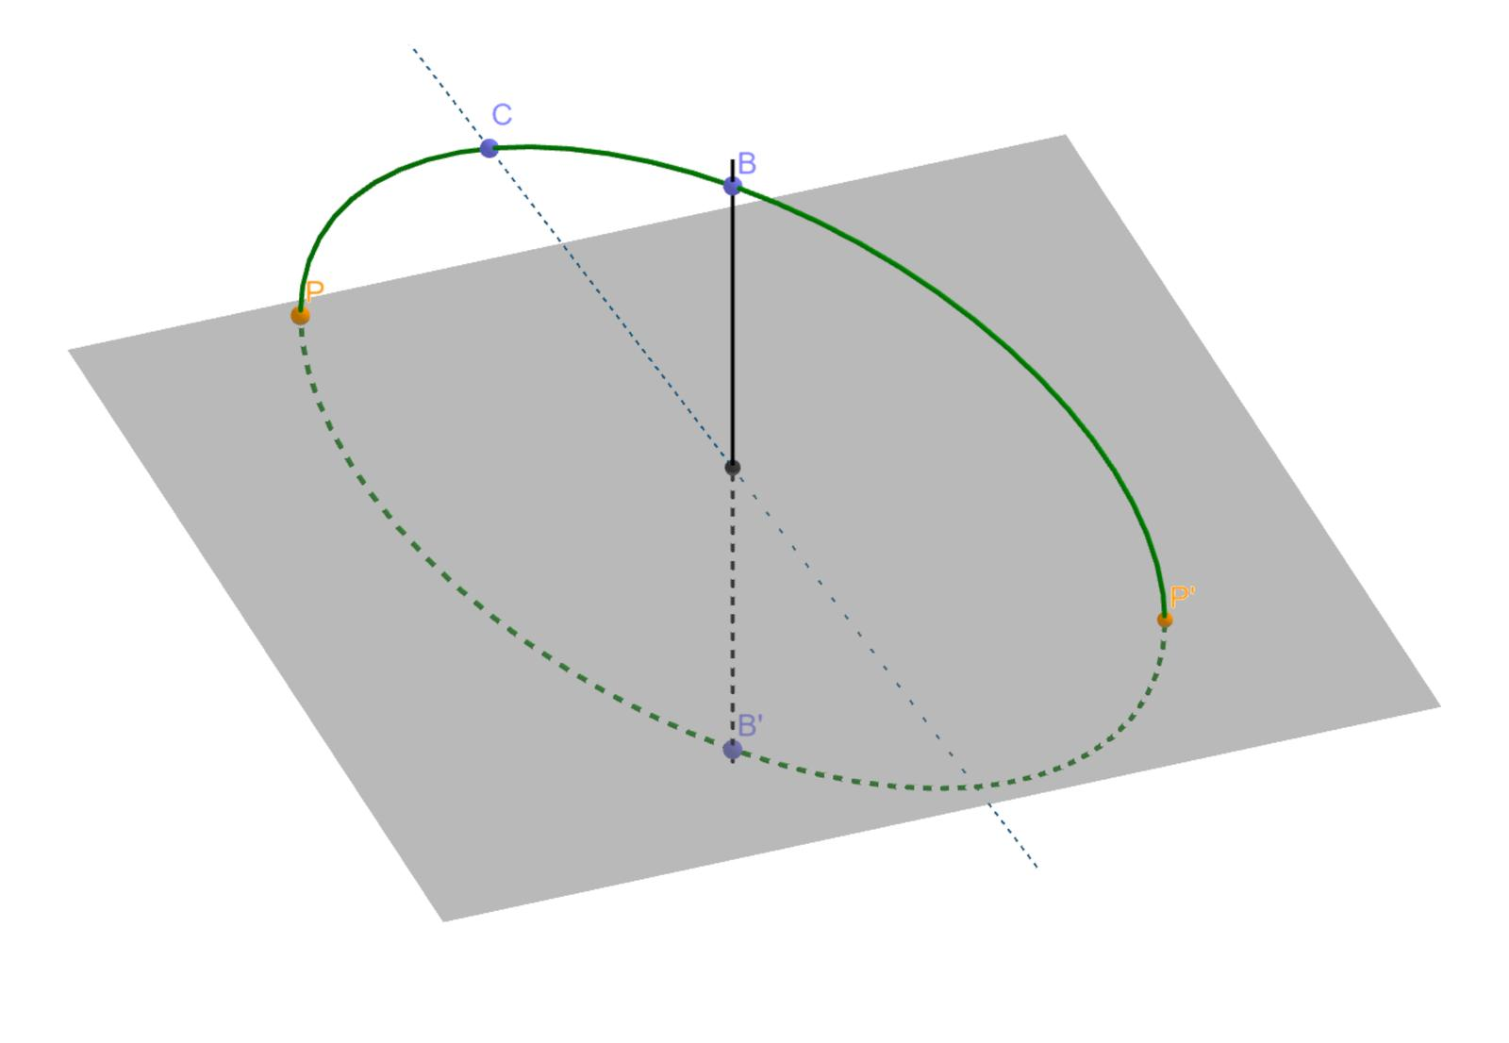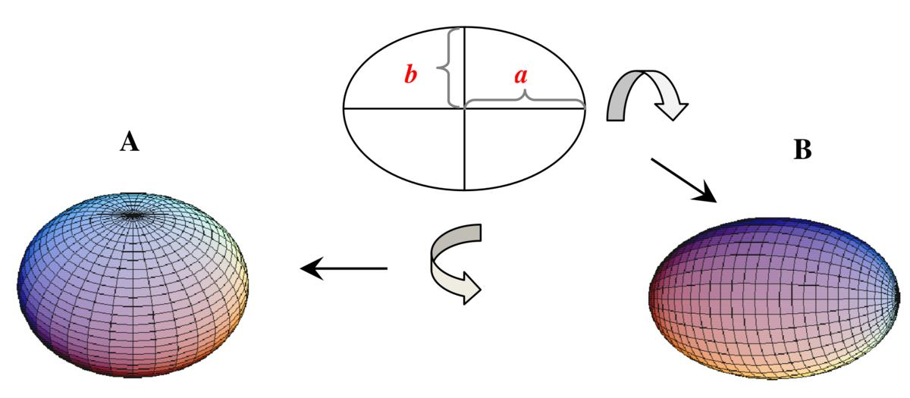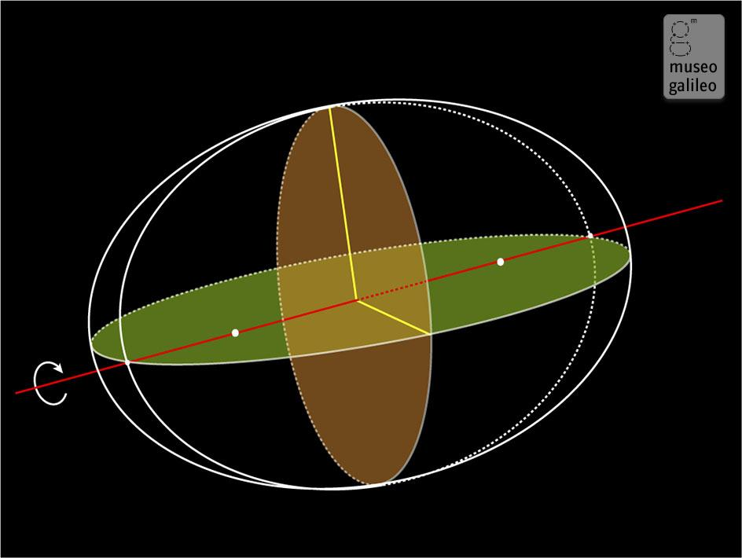
- Determine the required spheroid type:
- Prolate Spheroid: Longer along its rotational axis, resembling an elongated sphere.
- Oblate Spheroid: Shorter along its rotational axis, resembling a flattened sphere.
- Draw two perpendicular axes intersecting at the center.
- Mark the required semi-major axis $a$ and semi-minor axis $b$ using a ruler.
- Construct the complete ellipse using a compass, ellipsograph, or elliptical trammel.
- For a prolate spheroid, select the ellipse's major axis as the rotational axis.
- For an oblate spheroid, select the ellipse's minor axis as the rotational axis.
- Cut or prepare the elliptical profile from cardboard, plastic, or another suitable material.
- Attach the profile to a rotational frame along the selected axis.
- Rotate the elliptical profile through ${360}^{°}$ around that axis.
- Use the rotating profile as a guide to shape or demonstrate the resulting three-dimensional surface.
- Smooth the surface and verify its principal dimensions.

Method 2: Constructing a Spheroid Using Circular Cross-Sections
# Source: AI Source: Provided by: [Data Path: Persons Table -> ID Column: 1, Name_En Column: Motasem Essam] -> From: [ChatGPT] on [7/25/2026]
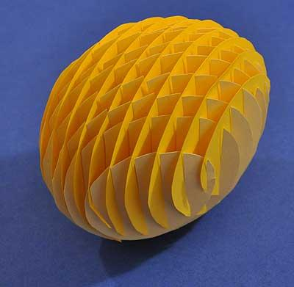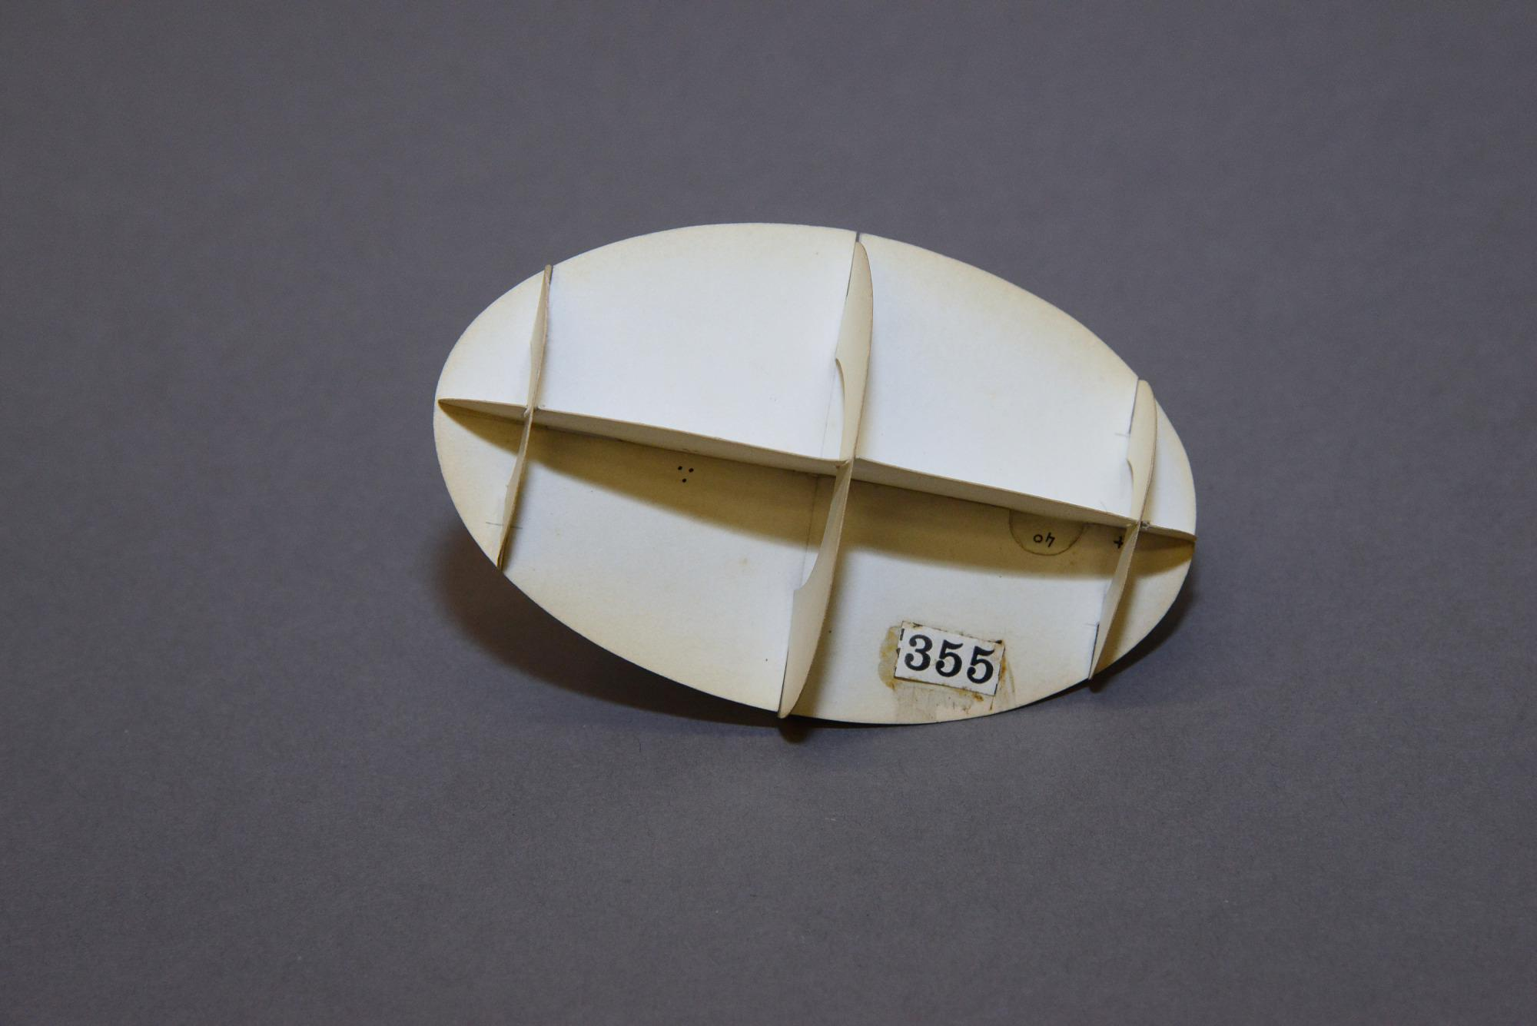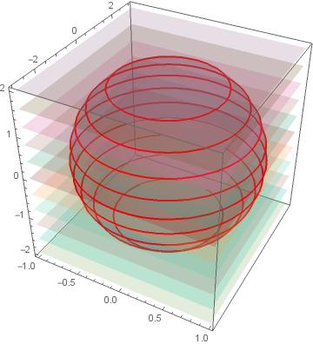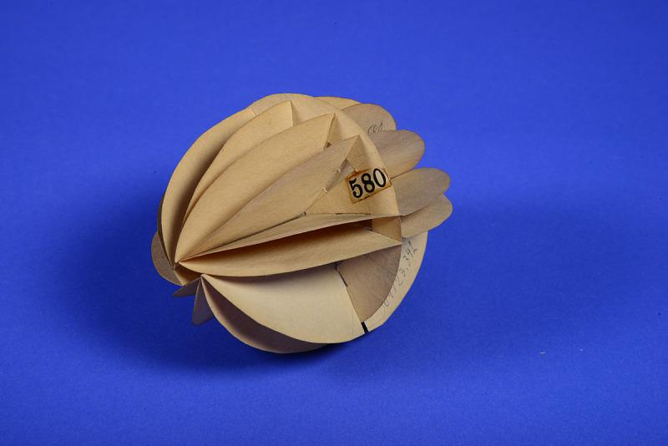
- Determine the spheroid's semi-major axis $a$ and semi-minor axis $b$.
- Draw the rotational axis using a ruler.
- Mark the center of the spheroid.
- Divide the rotational axis into several equal intervals using a ruler and compass.
- Draw perpendicular reference lines through the division points using a set square.
- Determine the radius of each circular cross-section according to the elliptical profile.
- Draw the circles using a compass or circular templates.
- Cut the circular sections from cardboard, foam, or another suitable material.
- Arrange the sections perpendicular to the rotational axis.
- Align their centers along the same axis.
- Arrange the sections symmetrically on both sides of the center.
- Join the sections and smooth their outer boundaries to approximate a continuous spheroidal surface.

Method 3: Constructing a Spheroid Using an Elliptical Trammel
# Source: AI Source: Provided by: [Data Path: Persons Table -> ID Column: 1, Name_En Column: Motasem Essam] -> From: [ChatGPT] on [7/25/2026]
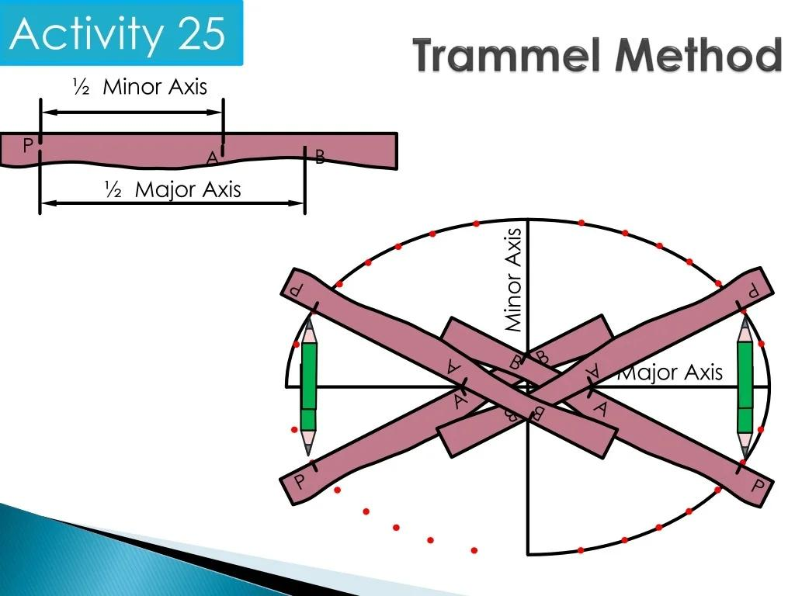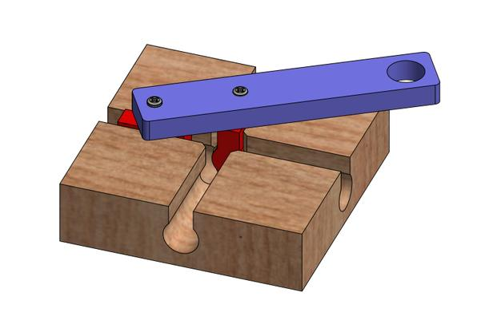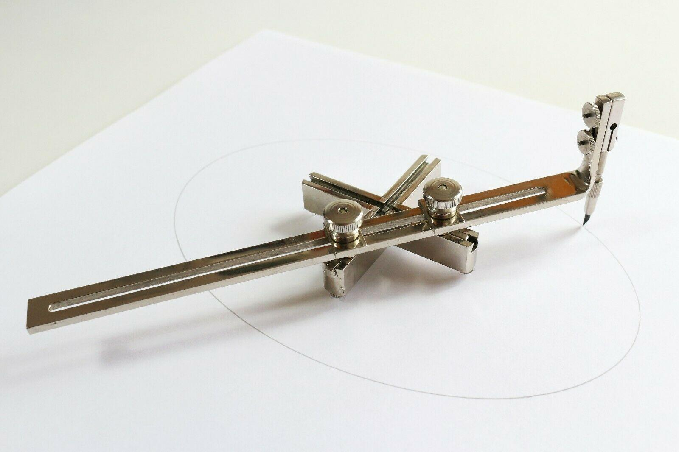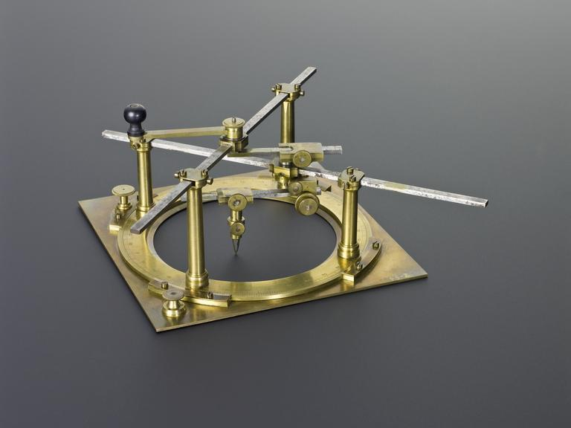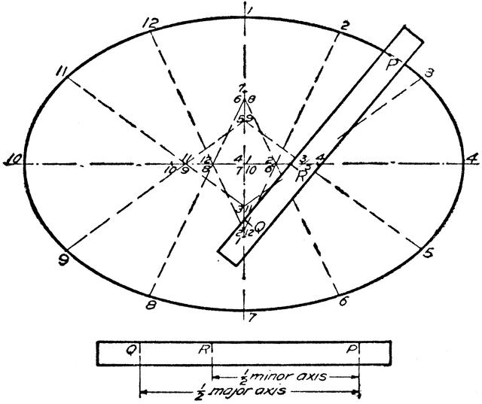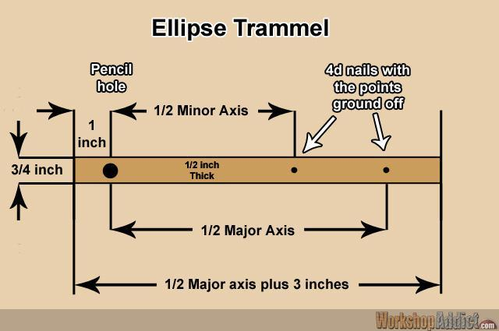
- Determine the required semi-major axis $a$ and semi-minor axis $b$.
- Draw two perpendicular axes intersecting at the center.
- Mark the endpoints of the major and minor axes.
- Position the elliptical trammel so that its sliding guides follow the two perpendicular axes.
- Adjust the sliding points according to the required axis lengths.
- Attach a pencil or tracing point to the designated drawing position.
- Move the trammel smoothly while keeping both sliding points on their respective axes.
- Trace the complete elliptical profile.
- Verify that the ellipse is symmetric about both axes.
- Select the major or minor axis according to whether a prolate or oblate spheroid is required.
- Use the ellipse as a profile for rotational construction around the selected axis.
The trammel method is a practical mechanical method for accurately drawing an ellipse.

Method 4: Constructing a Spheroid Using Pins and String
# Source: AI Source: Provided by: [Data Path: Persons Table -> ID Column: 1, Name_En Column: Motasem Essam] -> From: [ChatGPT] on [7/25/2026]
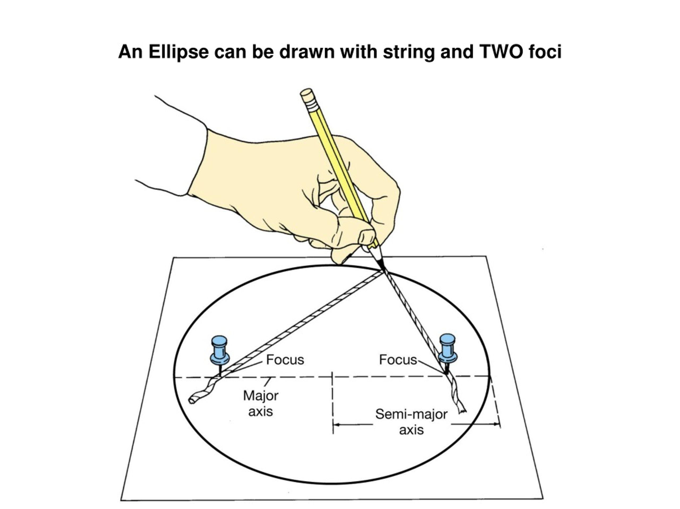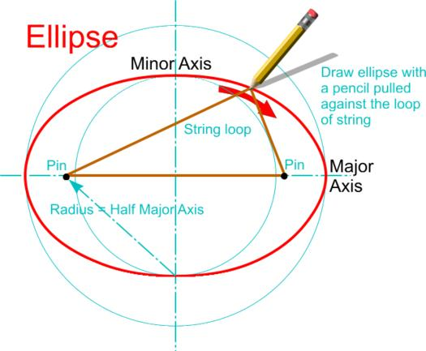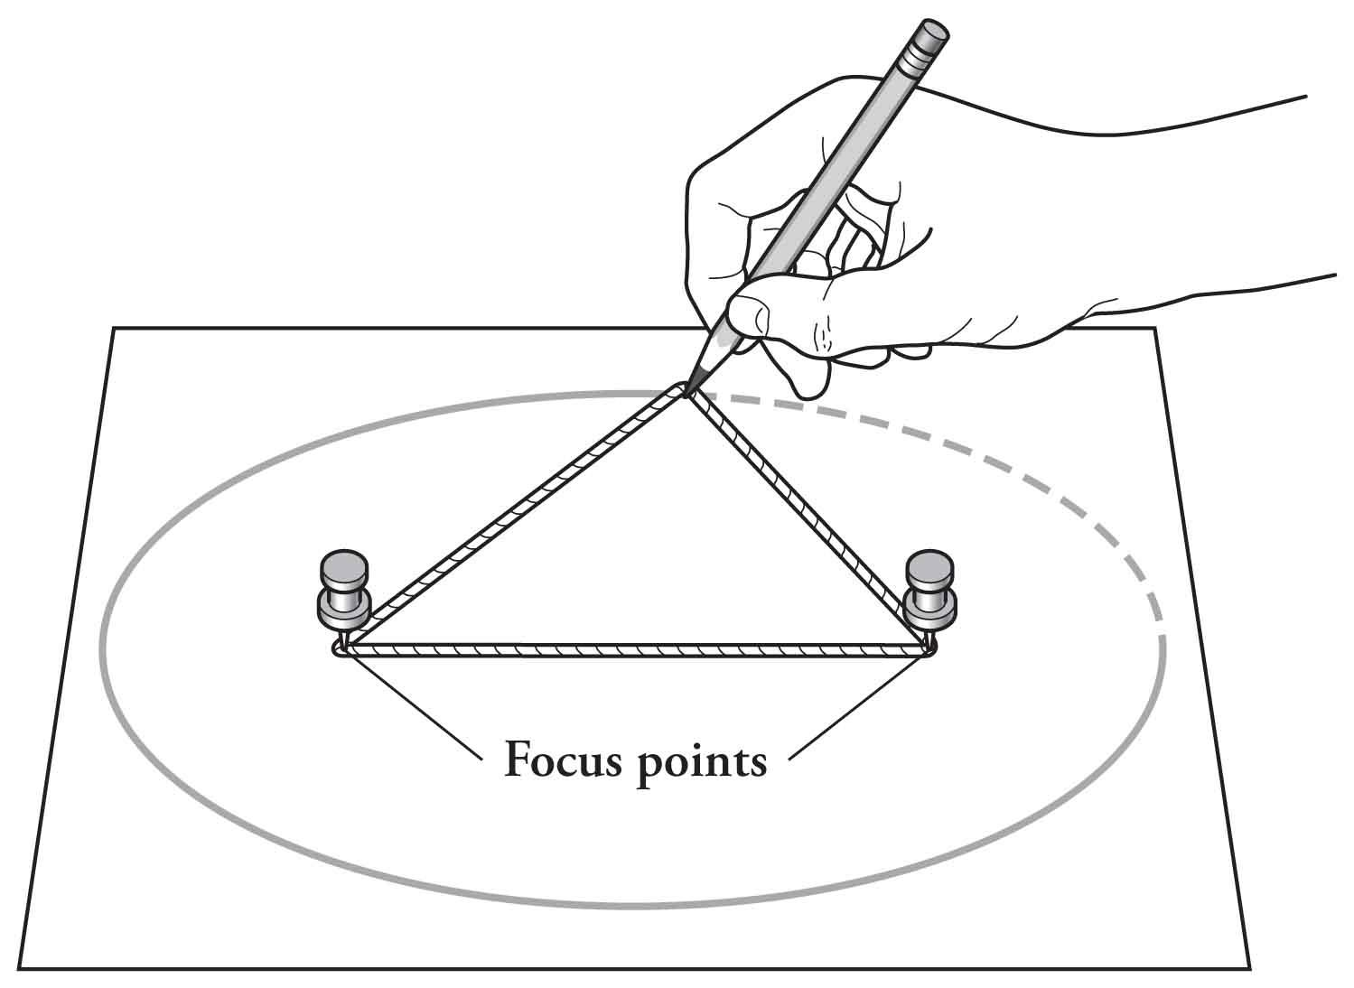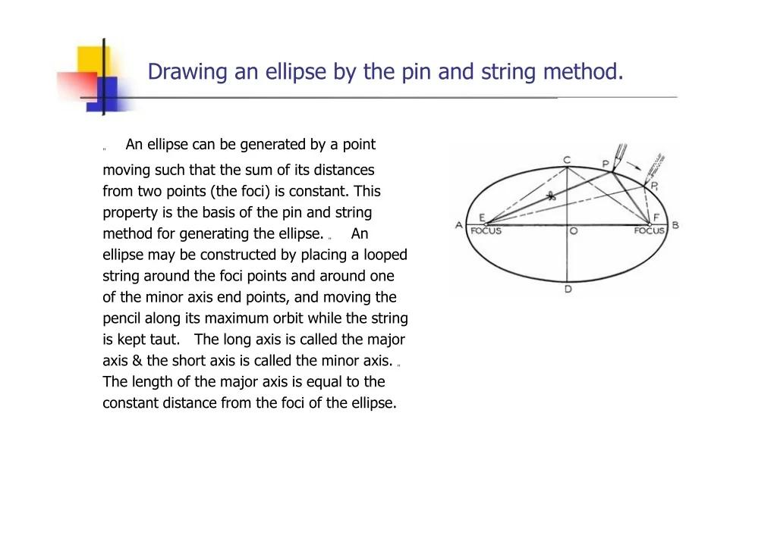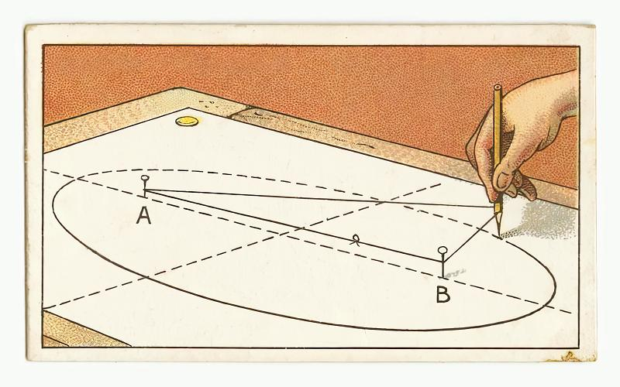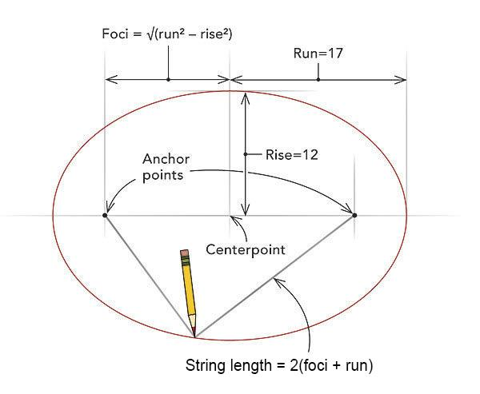
- Determine the required semi-major axis $a$ and semi-minor axis $b$.
- Draw the major and minor axes perpendicular to each other.
- Mark the center of the ellipse.
- Construct the two focal points symmetrically along the major axis.
- Fix a pin at each focal point.
- Attach a string between the two pins, allowing enough length for the pencil to trace the ellipse.
- Place a pencil inside the string loop and pull it taut.
- Move the pencil around the focal points while maintaining string tension.
- Trace the complete elliptical profile.
- Verify the profile's symmetry and dimensions.
- Select the appropriate rotational axis.
- Use the elliptical profile to construct the prolate or oblate spheroid through a complete ${360}^{°}$ rotation.

Method 5: Constructing a Spheroid Using Circular Templates
# Source: AI Source: Provided by: [Data Path: Persons Table -> ID Column: 1, Name_En Column: Motasem Essam] -> From: [ChatGPT] on [7/25/2026]
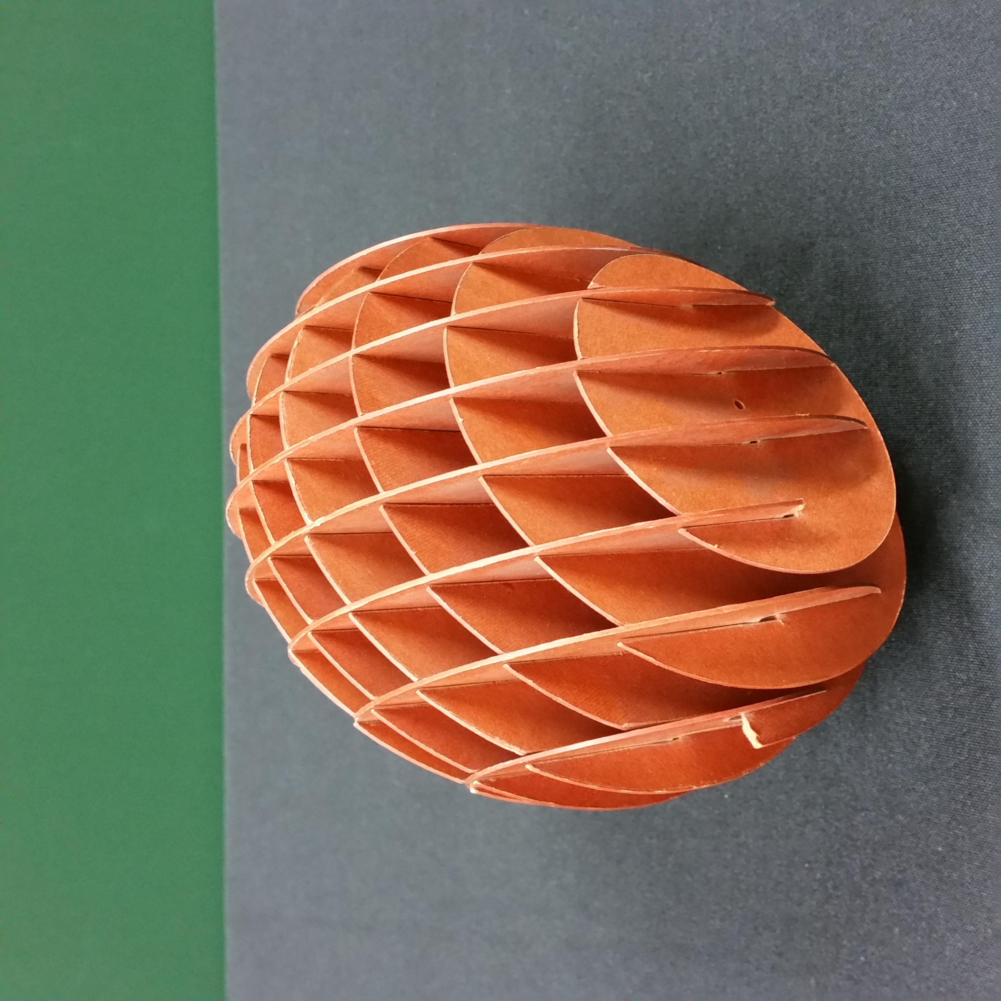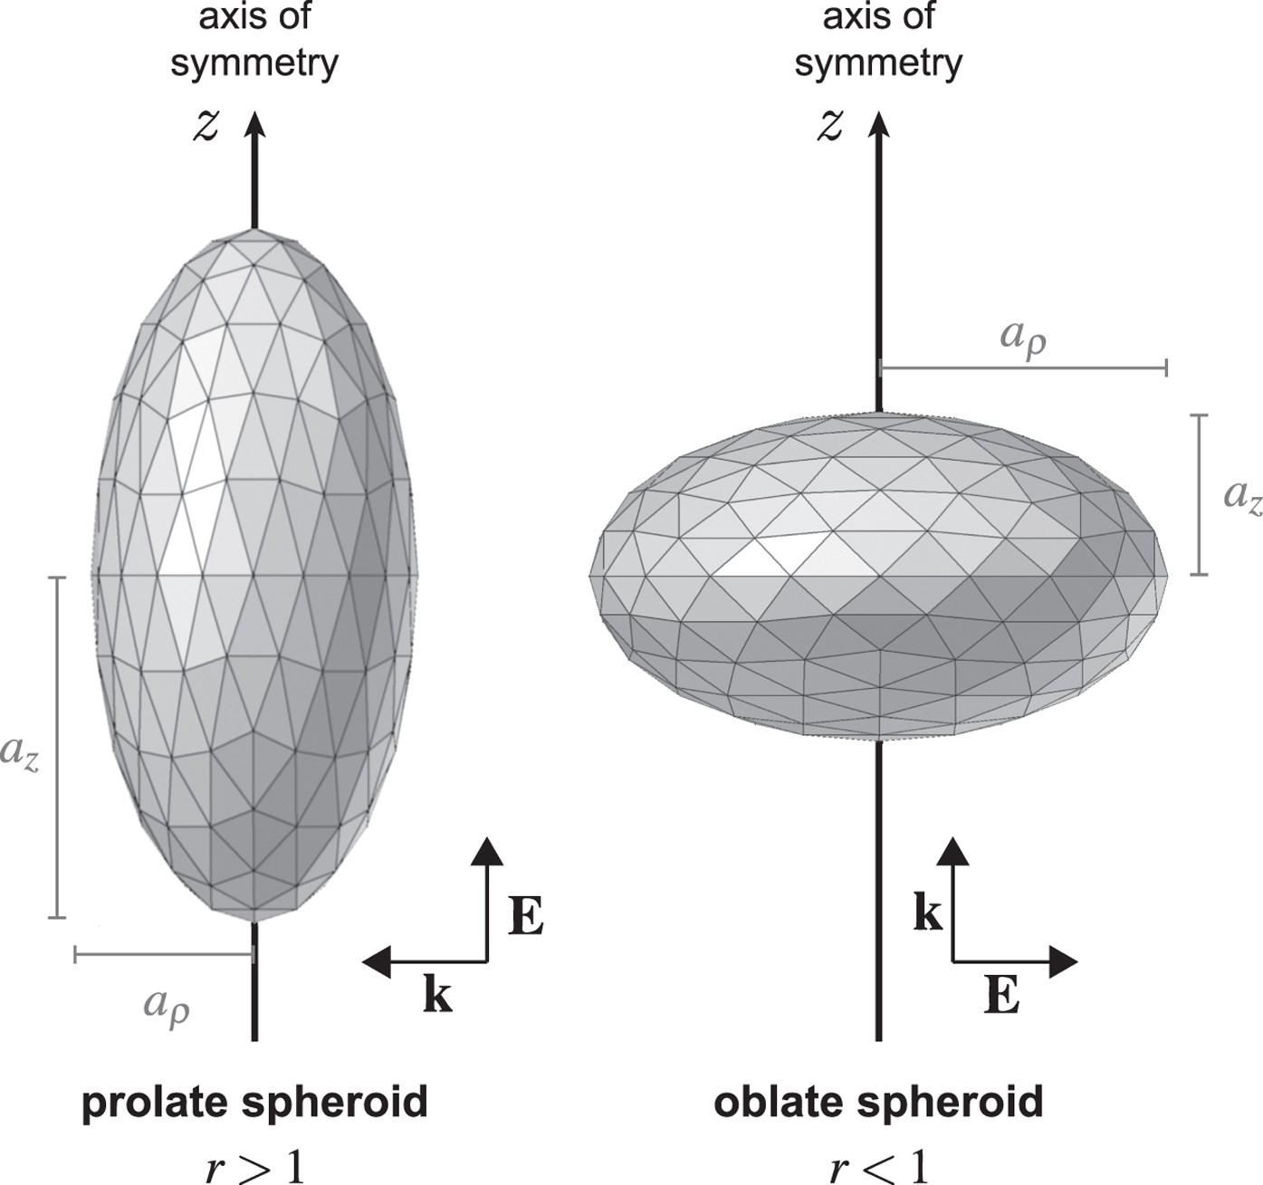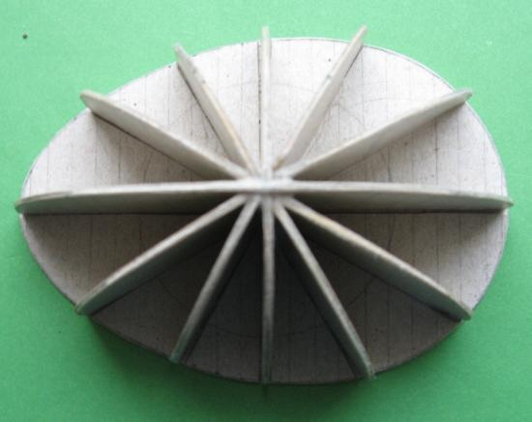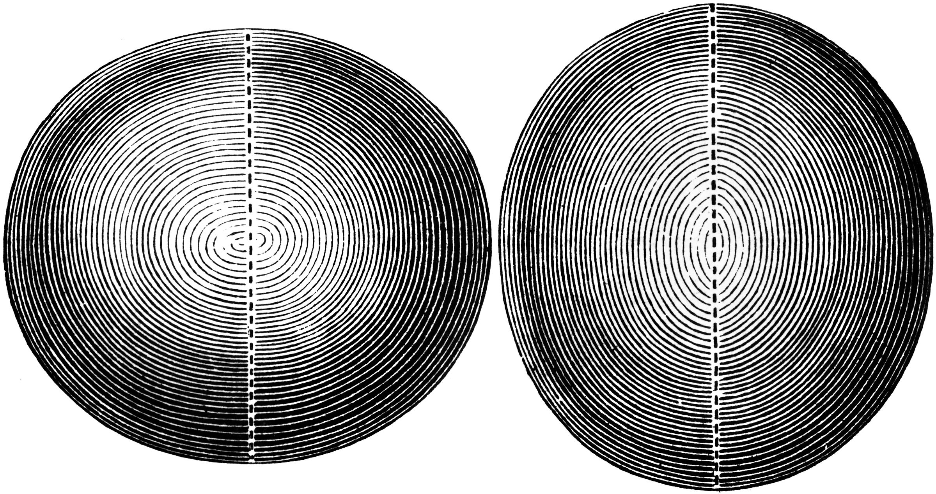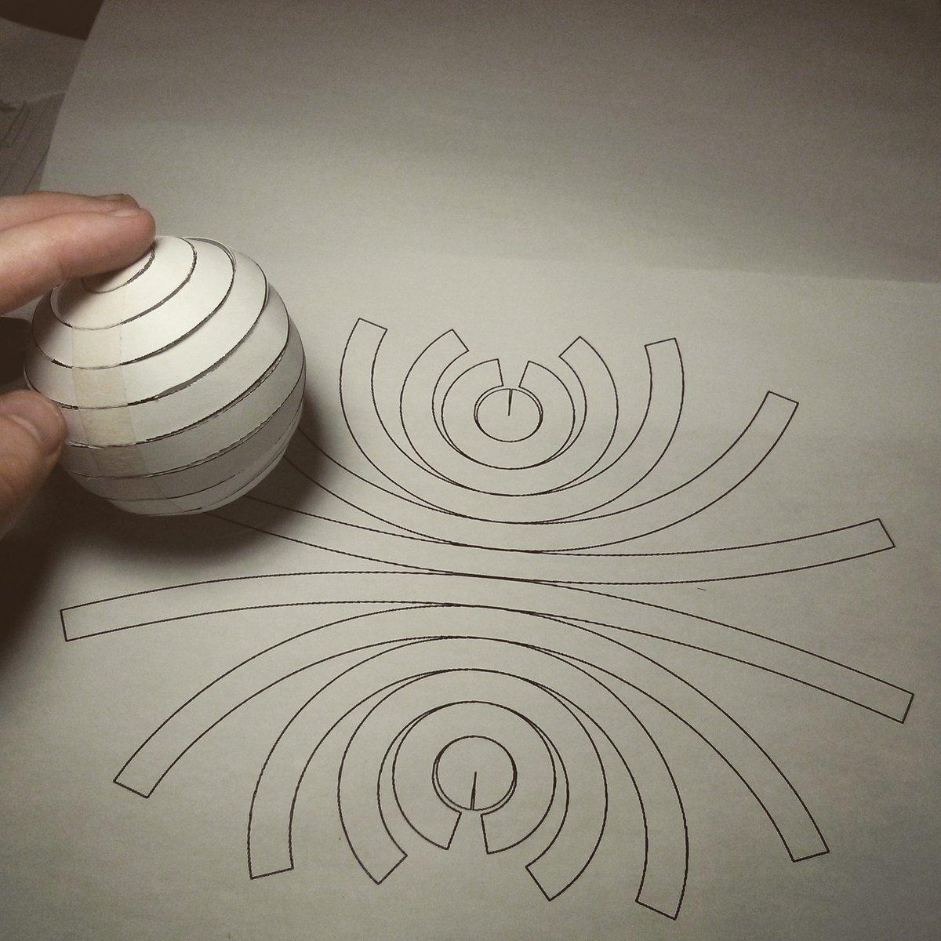
- Select the required spheroid type and dimensions.
- Draw the rotational axis and mark its center.
- Divide the axis into equal intervals.
- Construct perpendicular reference lines through the division points.
- Determine the radius of each circular section using the elliptical profile.
- Draw the circular templates using a compass.
- Cut the templates from cardboard, foam, or another suitable material.
- Arrange the templates along the rotational axis.
- Position the largest and smallest sections according to the selected spheroid type.
- Align all circular sections around the same central axis.
- Join the sections using adhesive or a central support.
- Shape and smooth the outer boundaries to approximate the spheroid.

Method 6: Constructing a Spheroid Using a Mold or Rotational Shaping Apparatus
# Source: AI Source: Provided by: [Data Path: Persons Table -> ID Column: 1, Name_En Column: Motasem Essam] -> From: [ChatGPT] on [7/25/2026]
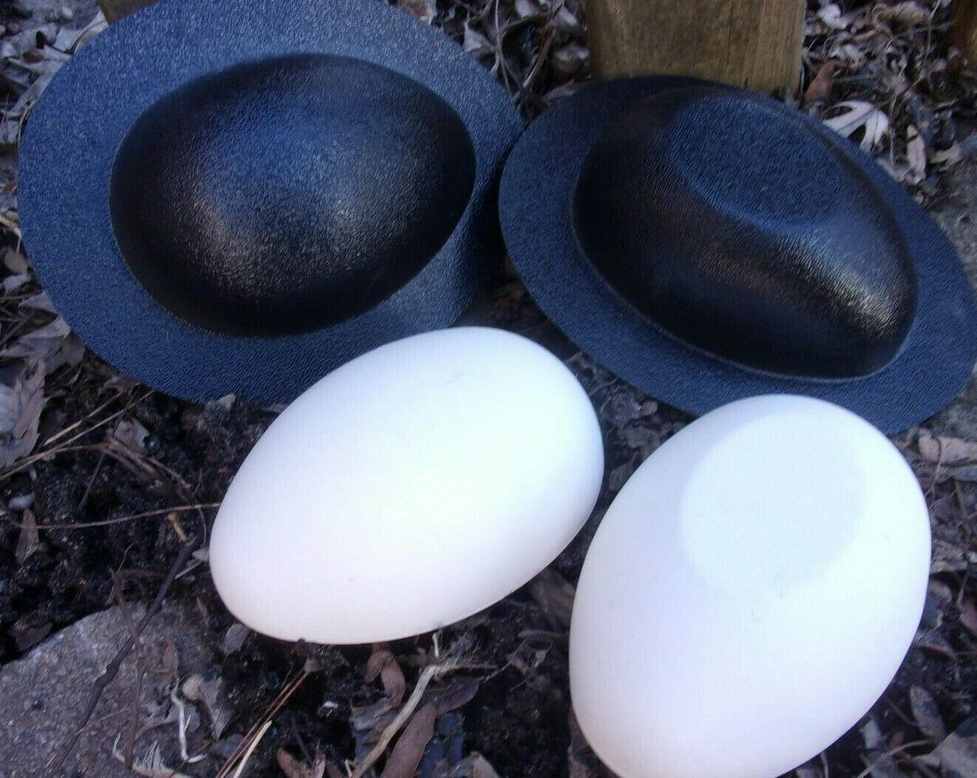
- Determine the required semi-major and semi-minor axis lengths.
- Prepare a mold matching the intended spheroid profile.
- Verify the mold's principal dimensions using measuring instruments.
- Align the mold sections along the intended rotational axis.
- Secure the mold or position the material on a rotational shaping apparatus.
- Fill the mold with a suitable modeling material, or shape the material using the rotating elliptical profile.
- Allow the material to set or harden when using a mold.
- Remove the mold, if designed to be removable.
- Smooth the surface and refine the joining boundaries.
- Measure the principal diameters to verify the final spheroid's dimensions.
Construction note: The major-axis rotation produces a prolate spheroid, while minor-axis rotation produces an oblate spheroid. Circular-section and template methods produce approximations unless the sections are sufficiently numerous and the surface is smoothly finished.

Comparison with Related Geometric Solids
# Source: AI Source: Provided by: [Data Path: Persons Table -> ID Column: 1, Name_En Column: Motasem Essam] -> From: [ChatGPT] on [7/25/2026]
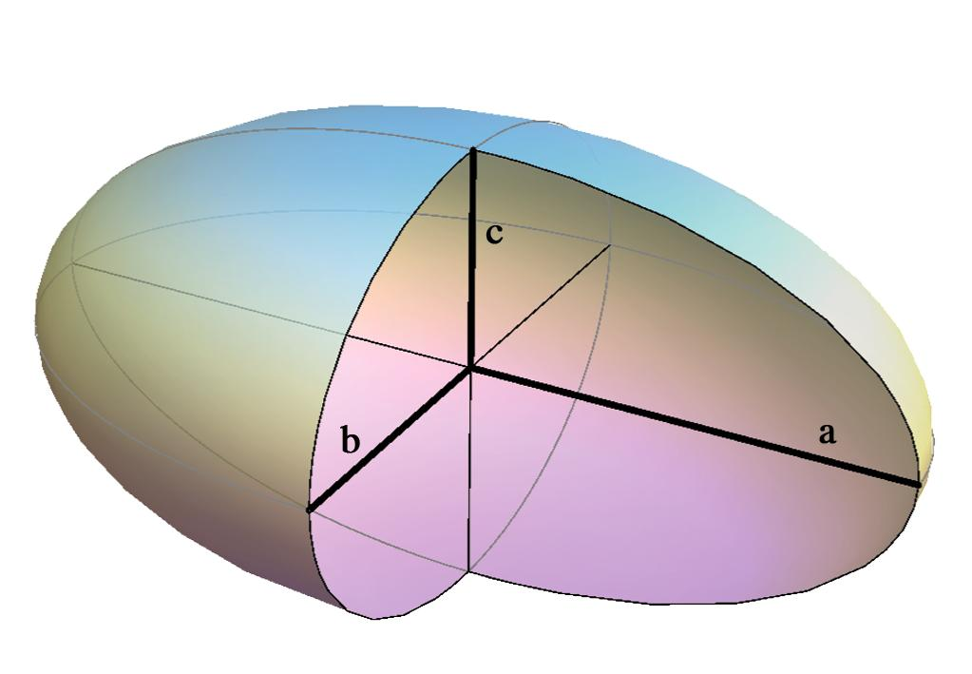
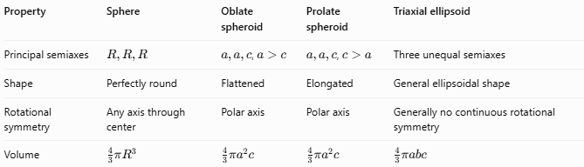
Property | Sphere | Oblate spheroid | Prolate spheroid | Triaxial ellipsoid
Principal semiaxes | $$R,R,R$$ | $a,a,c$, $a>c$ | $a,a,c$, $c>a$ | Three unequal semiaxes
Shape | Perfectly round | Flattened | Elongated | General ellipsoidal shape
Rotational symmetry | Any axis through center | Polar axis | Polar axis | Generally no continuous rotational symmetry
Volume | $$\frac{4}{3}{πR}^{3}$$ | $$\frac{4}{3}{πa}^{2}c$$ | $$\frac{4}{3}πa^{2}c$$ | $$\frac{4}{3}πabc$$
Important distinction: A spheroid is a special ellipsoid with two equal principal semiaxes. A general ellipsoid can have three different principal semiaxes and is not necessarily a spheroid.

Applications
# Source: AI Source: Provided by: [Data Path: Persons Table -> ID Column: 1, Name_En Column: Motasem Essam] -> From: [ChatGPT] on [7/25/2026]
- Geodesy: Approximating Earth with an oblate spheroid.
- Astronomy: Modeling approximately axisymmetric planets and celestial bodies.
- Physics: Representing certain rotating mass distributions.
- Engineering: Approximating components with rotationally symmetric shapes.
- Mathematics: Studying quadric surfaces, coordinate systems, volume, and surface area.

Key Points
# Source: AI Source: Provided by: [Data Path: Persons Table -> ID Column: 1, Name_En Column: Motasem Essam] -> From: [ChatGPT] on [7/25/2026]
- A spheroid is generated by rotating an ellipse around one of its principal axes.
- It has two equal principal semiaxes and one potentially different semiaxis.
- An oblate spheroid is flattened at the poles.
- A prolate spheroid is elongated along the polar axis.
- A sphere is the special case with equal radii in every direction.
- The volume of a spheroid is $\frac{4}{3}πa^{2}c$.
- A spheroid is a special type of ellipsoid, not a separate unrelated solid.

Conclusion
# Source: AI Source: Provided by: [Data Path: Persons Table -> ID Column: 1, Name_En Column: Motasem Essam] -> From: [ChatGPT] on [7/25/2026]
A spheroid is a three-dimensional geometric solid that generalizes the sphere by allowing the polar radius to differ from the equatorial radius. Its three main cases are the oblate spheroid, the prolate spheroid, and the spherical case. Understanding these distinctions makes it easier to classify rotationally symmetric solids and apply the correct mathematical formulas.

